Creating Beautiful Landscapes for Pollinator and Wildlife Habitat: Smithsonian Gardens to Your Front Yard
James Gagliardi
Supervisory Horticulturist, Smithsonian Gardens

Latin Rundown

False Blue Indigo (Baptisia australis)
Butterfly Weed (Asclepias tuberosa)
Columbine (Aquilegia canadensis)
Garden Phlox (Phlox paniculata)
Common Witchhazel (Hamamelis virginiana)
Common Milkweed (Asclepias syriaca)
Cardinal Flower (Lobelia cardinalis)
Pawpaw (Asimina triloba)
Brown-Eyed Susan (Rudbeckia triloba)
Scarlet Rose Mallow (Hibiscus coccineus ‘Blaze Starr’)
Buttonbush (Cephalanthus occidentalis)
Mountain Mint (Pycnanthemum muticum)
Boneset (Eupatorium perfoliatum)
Spice Bush (Lindera benzoin)
Red Chokeberry (Aronia arbutifolia)
Flowering Dogwood (Cornus florida ‘Jean's Appalachian Snow’)
Silky Dogwood (Cornus amomum)
Winterberry (Ilex verticillata ‘Red Sprite’)
Winterberry (Ilex verticillata ‘Winter Gold’)
American Beautyberry (Callicarpa americana)
Eastern Redcedar (Juniperus virginiana ‘Canaertii’)
False Soloman’s Seal (Maianthemum racemosum)
Trumpet Honeysuckle (Lonicera sempervirens ‘Blanche Sandman’)
Blackhaw Viburnum (Viburnum prunifolium)
Virginia Bluebells (Mertensia virginica)
Bloodroot (Sanguinaria canadensis)
Woodland Phlox (Phlox divaricata ‘Blue Moon’)
Colorado Blue Columbine (Aquilegia caerulea Songbird Mix)
Wild Geranium (Geranium maculatum)
Wild Geranium (Geranium maculatum ‘Espresso’)
Woodland Stonecrop (Sedum ternatum)
Paleleaf Woodland Sunflower (Helianthus strumosus)
Woodland Sunflower (Helianthus divaricatus)
Purple Coneflower (Echinacea purpurea ‘Ruby Giant’)
Bluestar (Amsonia hubrichtii)
Pink Muhlygrass (Muhlenbergia capillaris)
Goldenrod (Solidago rugosa 'Fireworks')
Prairie Blazing Star (Liatris pycnostachya)
Wild Bergamot (Monarda fistulosa)

Bees, Bugs & Blooms - Pollinator Plant Trial Results
Pollinator Plant Trial at Penn State Southeast Agricultural Research and Extension Center
http://ento.psu.edu/pollinators/resources-and-outreach/bees-bugs-blooms-2013-a-pollinator-trial

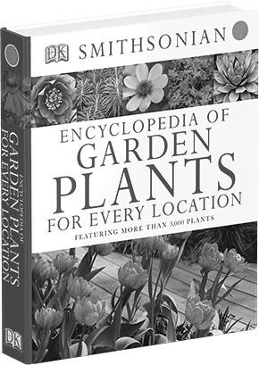
Encyclopedia of Garden Plants for Every Location
REVIEWS
"One of the hardest things to learn about plants is how to make them happy while maintaining your own sanity. The Smithsonian, then, has done us a great service with the Encyclopedia of Garden Plants for Every Location."
-Dominique Browning, The New York Times
"A colorful and highly useful reference. It's not just an encyclopedia of perennials, shrubs and trees, but an illuminating guide to using them in a variety of conditions and a wide range of garden styles."
-Beth Botts, Chicago Tribune
Discover more at: www.gardens.si.edu/book

